Chapter 3, Problem 81.

Use PSpice to solve the problem in Example 3.4

Example 3.4

Find the node voltages in the circuit of Fig. 3.12.

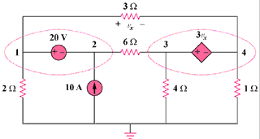

Figure 3.12
For Prob. 3.81.

